**Programming Development**

**Unit 4: Programming LAB**

**Assessor: Syeda Shamsia**

**Saif Khan 22003461**

**Learning Aim B: Design a software solution to meet client**

**requirements**

**Learning Aim C: Develop a software solution to meet client**

**requirements**

**Submission date: 20/02/2023**



**Content Page Page No**

**Introduction**  2

**Software development life cycle**  3

Analysis 3

Planning 3

Designing 4

Implementation

Testing & Integration 4

Maintenance 5

**Problem definition statement**  5

**Quad Diagram**  6

**User Interface Design** 7

Flow Charts  **7**

**Algorithm and Pseudocode and Flowcharts**  8

Scoring 9

Events 10

Players 11

**Programming Language**  12

**Test Plans** 13

**Test Plans**  13

**Screen shots** 14

**Annotating**  15

**Programme Interface 16**

Screenshots  **17**

**Evaluation 18**

**INTRODUCTION**

As a junior employee at a small software development company.The company recently visited a college.The college asked to create a scoring system for their tournaments .The clients want me to design and develop a computer program to manage the scoring system for the tournament and I have designed it to their requirements.

1.Made it easy to register the team or individual player in the tournament.

2.The college will be able to enter 4 teams and each team with 4 scores

3.Each event needs to be labelled either team or individual.

4.Team or individual will have 4 events to complete

**Software development life cycle**

The SDLC is used to organise the different stages of software development that ensures that all requirements are met.

**1.Analysis**

The first stage of the SDLC is analysis or identifying a problem that involves improvement of the current system by asking stakeholders, clients, salespeople and industry experts. This is one of the most important software development life cycle phases. What goal is intended to achieve and what are the required specifications to fulfil th

**2.Planning**

The 2nd stage is the planning stage that will involve figuring out the costs, time needed, the potential risks, resources and features required. This stage assesses how well it could be carried out and any plans just in case certain goals cannot be achieved.

**3.Designing**

The third stage is the designing stage which is turning the software specification into a design plan called the design specification. All involved parties can now review the design specification and suggest changes if needed. If this plan fails it could be very expensive for the organisation or the entire project can collapse.

**4.Implementation**

The fourth stage is building, which is the development of the actual software, precautions should be taken into considerations such as sticking to the plan, utilising widely used coding principles and ensuring that comments are used when necessary. An example of this is camelCase or underscores when naming variables; this will help the team to come up with organised and consistent codes that are easier to understand and test for the next stage.

**5.Testing & integration**

The fifth stage is code test, this is debugging which involves testing the code or the application to find any bugs and catch them before they release.

**6.Maintenance**

The sixth stage is software deployment which is using the software in a test environment or the staging environment. This ensures that the users can test the product while also it allows any deficiencies to be ironed out before the release. Software maintenance is also a part of Software deployment that involves fixing bugs as well as updating the software as the world around changes and updates. APM tools (application performance monitoring) can be used to monitor the performance and help optimise the application.

## **Problem definition statements:**

**What is the context of this problem?**

I am a junior employee at a small software development company . My company recently visited a local college and delivered a guest lecture. The college was pleased with the outcome of the visit and have asked my company to judge an upcoming event.

**What is the nature of the problem to be solved?**

The college will be running a tournament for students to win a set of prizes. I have been asked to create a computer program to manage the scoring system for this tournament

**What are the boundaries or scope of the problem?**

* One of the boundaries that I will be facing is the lack of specialised software in order to help with this task.
* I may also encounter various problems when it comes to storing large files.
* This task may consume a lot of my time so I will need to manage it very well
* Another problem when trying to accomplish this task is the lack of knowledge with the software or tools used
* The program needs to be eye catching for the user

**What requirements are defined by the client?**

The participants need to be able to enter as part of a team or individual or a team. There will be four teams to select from.

The users must be able to add a new event for either a team or individual. The users need to be able to enter the scores of the individuals or teams and then get a result of who won or lost

**What are the benefits of solving this problem?**

One of the benefits of solving this problem is that it will make it easier to manage another contest because it has systems that let users be added into teams or individuals and also has a scoring system and also has the ability to add new events. This makes it good for almost any kind of contest. As the system can just be adapted for the current contest

**What is the impact of not solving this problem?**

It may be difficult to organise other events and keep track of scores participants and events for people managing the contest

**What is the purpose of the required solution?**

* It will help people to manage events which involve lots of participants and a scoring system and an event system.
* Test plans
* Flow charts
* Screen design
* Pseudocode
* Error reports

**What is the nature of the interactivity between the target users and the solution?**

* Produce a design for the tournament scoring system application including clear and effective diagrams, illustrations and algorithm designs.
* Following the design I will develop the tournament scoring system application. I will implement the program to provide the functionality required by the college.
* I also need to show how I have taken individual responsibility and effectively managed myself while completing this assignment.

**Quad diagram:**

| Input required  A username needs to be entered | Processes required  A check for entered text |
| --- | --- |
| Output required  A message greeting the user  An error message asking the user to enter a name | Data Storage required  none |

**User Interface Designs:**





**Flowchart:**



**Algorithm and Pseudocode:**

DO

Ask the user if they are entering as a team or individual IF

Text field is empty

OUTPUT (“please select team or individual”)

ELSE

OUTPUT(“please enter a name”)

ENDIF

WHILE

Username empty

**Screen design for adding, calculating and showing score**



**Flowchart for scores**



**Algorithm and Pseudocode:** Scores:

DO

Ask the user to enter the fist score IF

Text field is empty

OUTPUT(“please enter a score”)

ELSEIF

OUTPUT (“enter a second score”)

ELSEIF

OUTPUT (“enter a third score”)

ELSEIF

OUTPUT(“enter a fourth score”)

ELSE

OUTPUT(“continue”)

ENDIF

WHILE

First score is empty

**Design screen for creating events**



**Events flowchart**

**Pseudocode: Event**

DO

Ask the user to add a new event IF

Event name is empty

OUTPUT(“please enter an event name”)

ELSE

OUTPUT (“please select if this is a team event or individual event”)

ENDIF

WHILE

Event name is empty

**Programming language**

| **Language** | **Application area** | **Advantages** | **Disadvantages** |
| --- | --- | --- | --- |
| **Java** | Java is used to create applets for Android mobile apps and  web pages. As it is “WORA” write once run anywhere, so it is  used in many home entertainment devices such as TV set-top  boxes etc. | Robust  Infinitely scalable | Complex  Resource hog  Doesn’t work for older systems |
| **C** | C which is considered as a general-purpose language. It is  low-level control of the computer system therefore it is effective for controlling hardware electronics. | Intuitive  Less complex  Better for low level programming  Fast | Difficult to make web applications |
| **C#** | C# is used to create video games for Microsoft Windows and popular games consoles, particularly because of its ease of use with Microsoft’s XNA. | Uses C++ as a foundation to build on  Builds web based applications very well | Locks you to the Microsoft platform |

**Test Plan: Screen shots**

**Test Plan**

| **Test**  **No** | **Type of test**  **(N, R, X)** | **Test data** | **Expected results** | **Add screenprint(s) of the results of this test (and any retests) Ensure you show the test data used in the screenprint(s)** |
| --- | --- | --- | --- | --- |
| **1** | **n** | **Ask the user to enter a player name** | **An error message will appear asking the user to enter a player name** |  |
| **2** | **n** | **Ask the user to enter a team name** | **An error message will appear asking the user to select a team** |  |
| **3** | **n** | **Ask the user to add a event name** | **An error message will appear asking the user to enter an event name** |  |
| **4** | **n** | **Ask the user to add a new event** | **An error message will appear asking the user to add a new event** |  |
| **5** | **n** | **Ask the user to enter the first score** | **An error message will appear asking the user to enter the first score** |  |
| **6** | **n** | **Ask the user to enter the second score** | **An error message will appear asking the user to enter the second score** |  |
| **7** | **n** | **Ask the user to enter the third score** | **An error message will appear asking the user to enter the third score** |  |
| **8** | **n** | **Ask the user to enter the fourth score** | **An error message should appear asking the user to enter the fourth score** |  |
| **9** | **r** | **Ask the ussr to enter player name** | **An error message will appear asking the user to enter their name in letters** |  |
| **10** | **x** | **Ask the user to enter a team** | **An error message will appear asking the user to select a team from the available options** |  |
| **11** | **x** | **Ask the user to enter a player name** | **An error message will appear asking the user to select form the list of events** |  |
| **12** | **x** | **Ask the user to enter a team name** | **An error message will appear asking the user to select either theme or individual event** |  |
| **13** | **x** | **Ask the user to enter the fist score** | **Ask the user to enter a valid score** |  |
| **14** | **x** | **Ask the user to enter the second score** | **Ask the user to enter a valid score** |  |
| **15** | **x** | **Ask the user to enter the third score** | **Ask the user to enter a valid score** |  |
| **16** | **x** | **Ask the user to enter the fourth score** | **Ask the user to enter a valid score** |  |

# 

**Program interface**

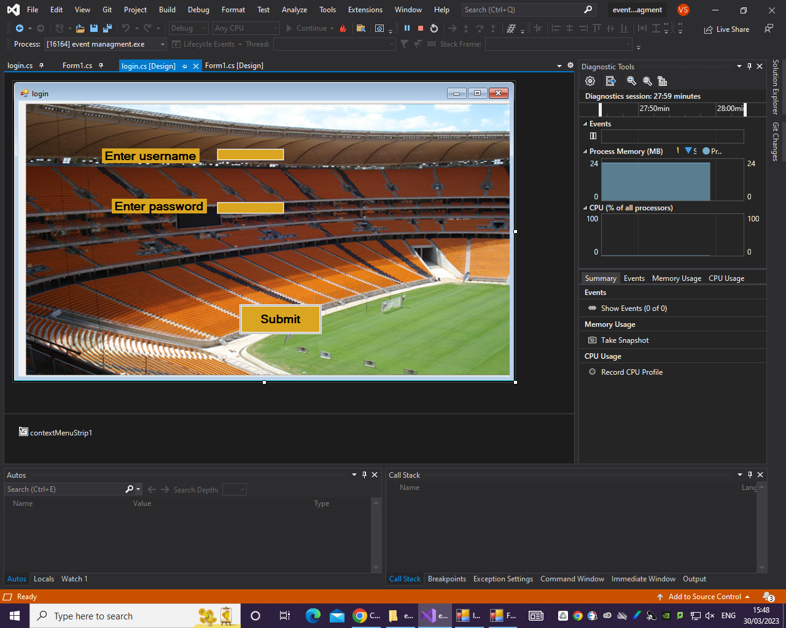

For this program I decided to create 2 separate forms. One of these forms is the login form. The login form consists of various elements such as a picture box for the background image mage. After creating the picture box you right click on the picture box and then select the image. Once you do that you should see a pop up window.

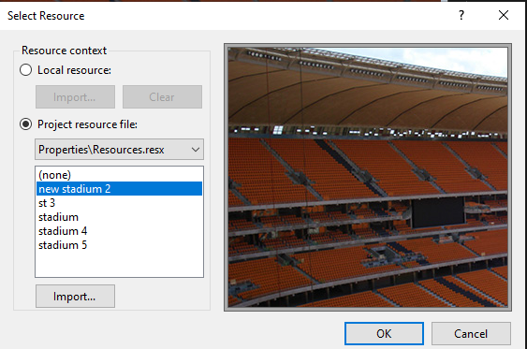

In the pop up window you should see a white box which is usually empty. Under the white box you will see a button called import. Click the import button a window should pop up allowing you to browse your files, you can then find your rummage and select it and click it, after selecting your image should pop up on the right hand side of this window. Once you are happy with everything you can then click OK to apply the image. When you create the picture box it will go on top of the other elements of your page, in order to move to show everything else, you can right click the picture box and click send to back. Once you are done, all the other elements should reappear.

The login page also contains labels and text boxes, the labels can be used to identify what the textboxes are for. A button is the final element that is used to validate the entries in the text box and move you to the next form.

If you double click the button

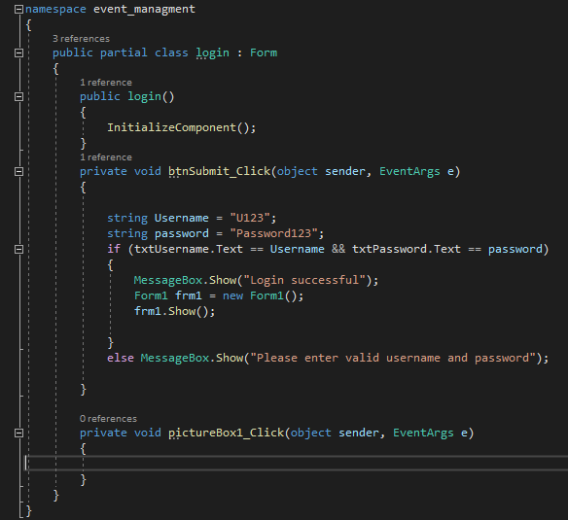

If you double click the button you should get a new window this is where you can enter your code. All the code within the curly brackets will be executed. The IF statement is used to check if what is written in the text boxes is equal to U123 and Password 123. If the entries into the text box are will to U123 and Password 123 the a message box will appear saying login successful and you will be able to move to the next for,

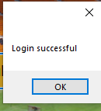

otherwise an error message will appear

asking the user to enter the correct username and password.

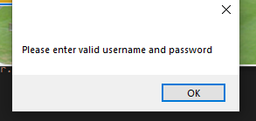

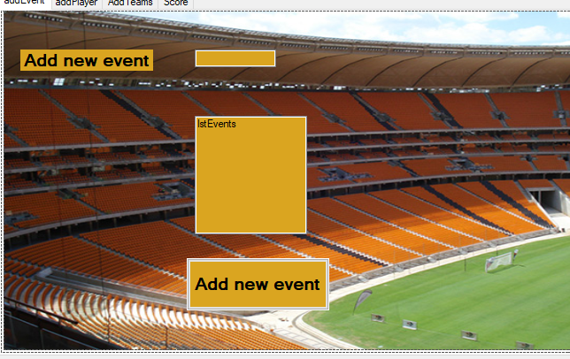

I also created a second form for entering various pages of information such as adding a new event, a new player, a new team and scores.

This form consists of a tab control which allows you to have different tabs to split information into. I also used another picture box on each tab for this form. I also used more textboxes and labels. However a new element that was not in the loginform was the list box. The list box is used to store the information that is entered into the text box a list box is used on each tab in order to store the information entered into the text box

These elements can be forums within each tab.

Once I was happy with everything I double clicked the button and that gave me a window to code in.

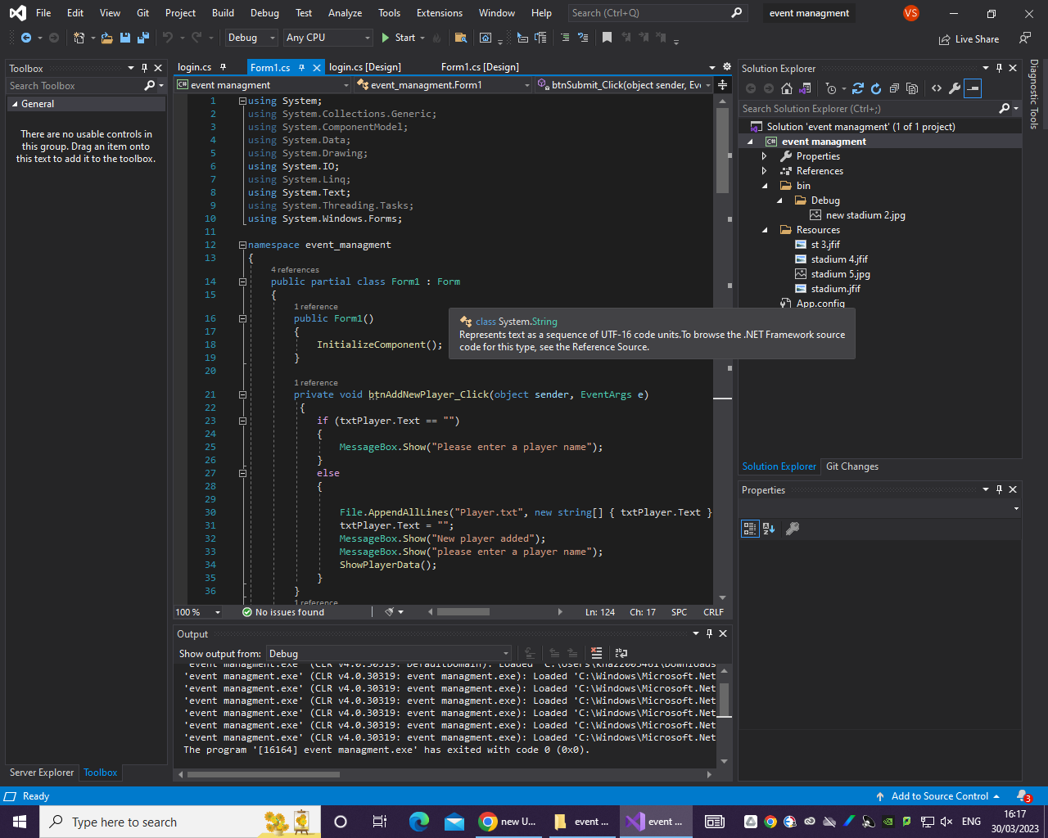

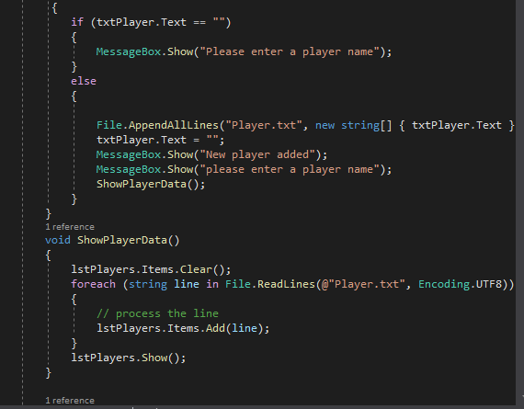

This is an example of some of the code that. I typed for the add player tab. I check to see if a player name was added into the text box. If it detects a name it will show a message box saying that a new player was added and then it will be added to the list.

I did the same for all the other tabs such as add team.

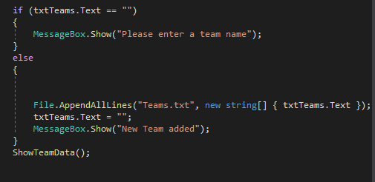

This is the code used to allow you to enter a team name into the text box and it will be saved into a list after you enter a team name, when you click the button then it should say that a new team has been added. If there is nothing in the box then a message will appear asking you to type something into the box.

I used mostly the same code with a few differences for the add event page.

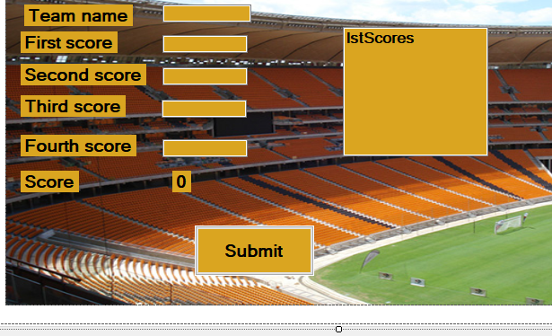

This is the scores page. When the button is clicked it will play a total of all the scores that have been entered into the boxes.

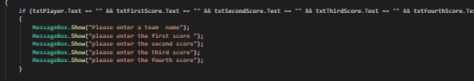

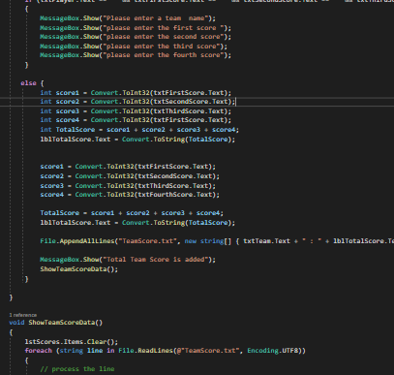

This is the code for the scores page. I will check if all the necessary scores have been entered. Once all the scores have been entered, the total will be displayed at the

bottom as well as in a list.

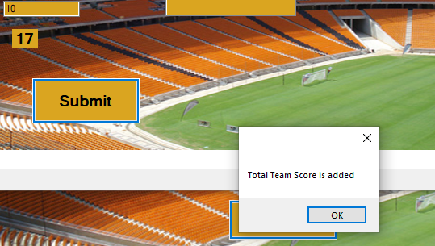

**TimeLine (GANTT Chart)**

| **Tasks** | **Start date** | **End date** |  |
| --- | --- | --- | --- |
| Started Unit 4 programming LAB/C  Introduction | Jan 09 | Jan 11 | No issues |
| Introduction | Jan 12 | Jan 25 | No issues |
| Quad Diagram | Jan 29 | Feb 15 | No issues |
| User Interface | Feb 15 | Feb 27 | No issues |
| Flow charts/ pseudo codes | Feb 27 | March 20 | Flow charts were easy/small issues with coding, struggling with some functions but with teacher;s help resolved. |
| Coding | Apr 05 | Apr 28 | Some i struggled |
| Test Plans | May 1 | May 03 | No issues |

**Demonstrate individual responsibility, creativity and effective self-management in the design, development and review of the computer**

**Program**

One of my primary worries while developing the programme was time management because, in addition to it, I had to concentrate on other projects and strike a balance between them.

I think I did a great job of managing my time while working on this project. I had more time to devote to this project because it was the holidays.I had written the programme/screenshots in college, but to compare the programmes I needed access to visual code.

Each programme, along with all the coding requirements, took time to finish. I started by making a player system, then I moved on to the others. Before developing the programme, I made a schedule in which I designated time for each task, which assisted me in completing my assignment, as well as the days I would complete these tasks and the duration for each task. I also discovered that when I tried to work ad hoc without adhering to the schedule, I tended to produce shoddy work, which made it difficult to get back on track.

Furthermore, I utilised Google Docs to do this programme evaluation because it is simple to use as long as I have access to the internet.

**Individual performance/Time managing during the project**

In regards to communication and professionalism, I kept the project open allowing team members to submit suggestions and changes. I ensured that the project was always on track, I also helped team members with various parts of the project. I practised at home after seeing some tutorial videos on youtube for using visual studio. I had to work extra lessons in LRC to gain extra practice. I was asked by my college instructor if I had encountered any problems when programming. In regards to the creation of this document I used google docs. I used google docs because it is integrated with google drive and as a result I can access it from almost anywhere as long as I have an internet capable device. I also asked for help when I needed it and made sure to help others when they needed it. As a result I learned more about the problem by helping others.

I was able to improve the design of the program by taking in feedback from others. I corrected my flaws and sharpened my talents by seeing the adjustments.I was able to fix my friends' codes and make them work when they sought my assistance. My ability to solve problems and analyse data was enhanced by this.

In order to gain some information. In order to create the program I used C#, this was not the first time I had done programming, this made the project slightly easier because I already understood some of the principles of programming. Overall I think I did well managing the project. I did this by communicating the project vision to the people that I was working with. I was receptive to feedback from peers and made adjustments based on feedback

**Evaluation**

I have considered the clients desire for something user-friendly so that when someone checks in, they know exactly what they want to access. I am convinced that this programme will be suitable for smartphones in the future given the mobility of my design because the interface can be modified to work with these devices, increasing the likelihood that this software will run on them. Because it might be improved, I believe the design I went with is suitable for portability.The client will feel at ease using the programme because of the colours, the design, and the buttons. The design is applied consistently to every page. When a programme is user-friendly, intuitive, and has straightforward navigation, it has a good layout. A crucial quality is being clear. It must have a clear message and clear style and layout to convey what you want it to express. If the design does not clearly communicate with the client, it is useless because the client will not comprehend.

Accuracy must be verified after the programme has been written to ensure that the code is error-free. They must be accurate in terms of design to match how the final programme should seem once it has been produced.

I believe I managed my time well while working on this assignment. It was a holiday, so I had more time to devote to this project.I had written the program in college, but to compare the programmes I needed access to a visual studio.

It required time to complete each programming and all the coding requirements. I first created a player system before moving on to the others. Prior to creating the software, I created a plan in which I listed all of the actions that would help me finish my assignment, along with their respective durations and due dates. In addition, I found that when I tried to work ad hoc without.

Furthermore, I utilised Google Docs to do this programme evaluation because it is simple to use as long as I have access to the internet.